**Reshma reddy**

**CS5551 Lab Assignment – 2 Report**

In this Lab Assignment -2, I created an app that helps the user in finding way to get the current location and weather at that location. I have used Google Maps web services and Yahoo weather web services for this application. I have created the application by making use of HTML, CSS, Javascript and JQuery Mobile.

In this application, the user has an option to check weather or the location. And it has a home button to back to the home page after selecting a button that is either weather or current location.

Also, as advised I have used Opera Mobile Emulator for seeing the application in a mobile interface and the screenshots of the Opera Mobile emulator are also presented below.

**Jsfiddle.net Link:** <http://jsfiddle.net/EHj7B/1/>

**Screenshots from Jsfiddle.net:**

1. The user is at the Home page by default and he can come back at any point of time to this page by clicking the “Home” button at the top left of every page.

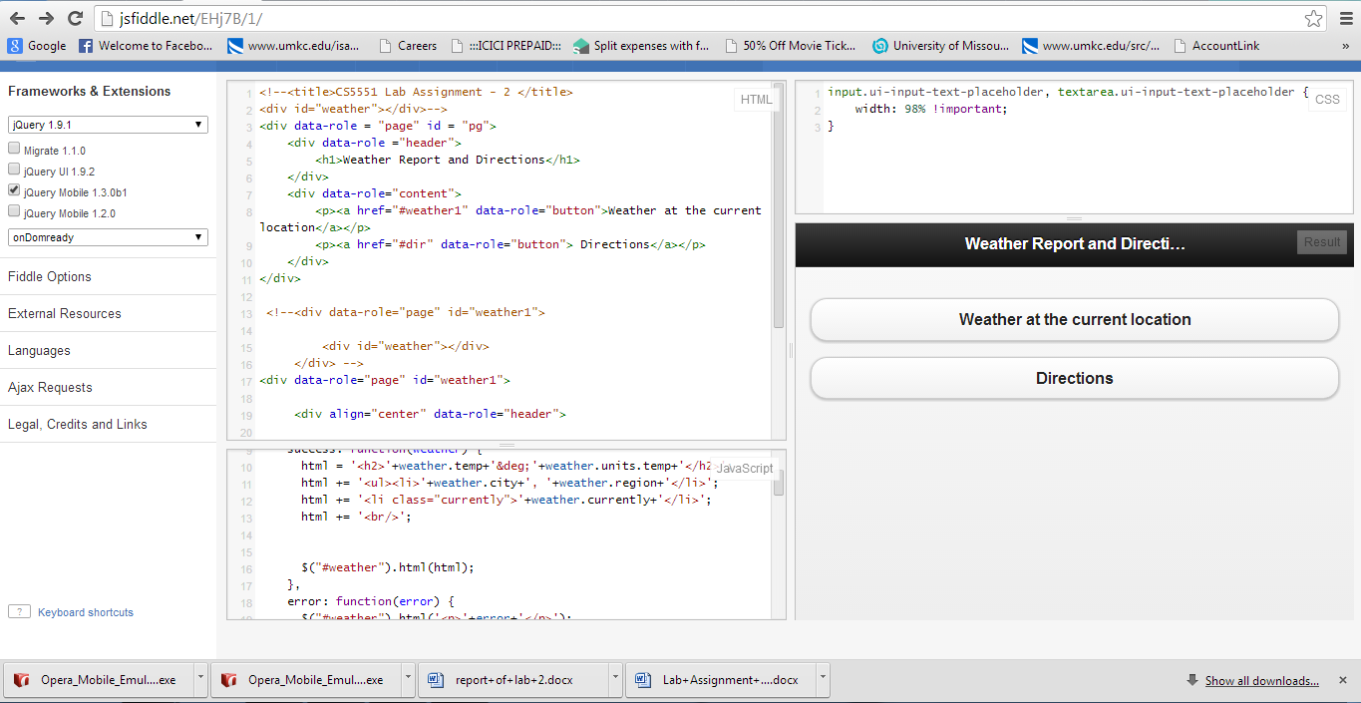

1. The user has the option to click for Directions where he can see the current location.

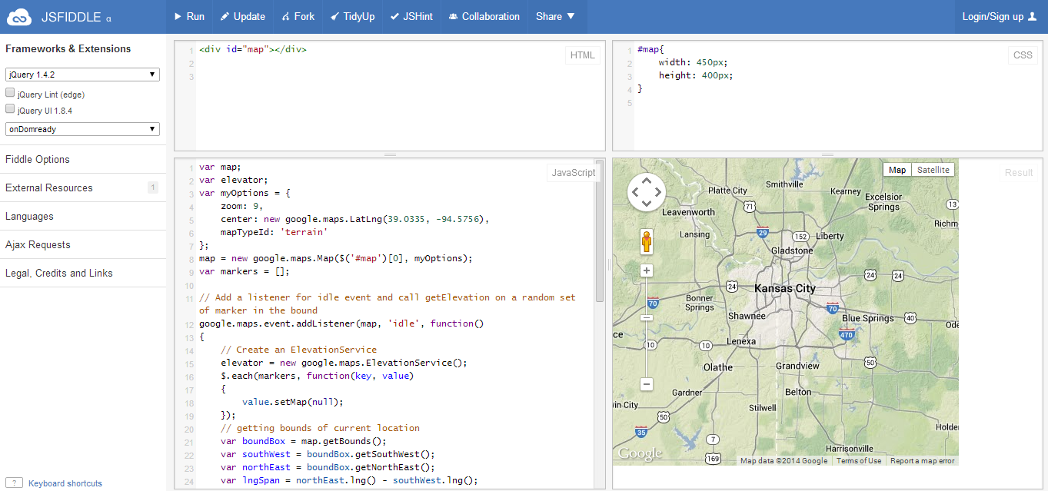

1. The user then has the choice to see the weather conditions at the current location. In this case it is Kansas city and shows that weather is 18 degree f.

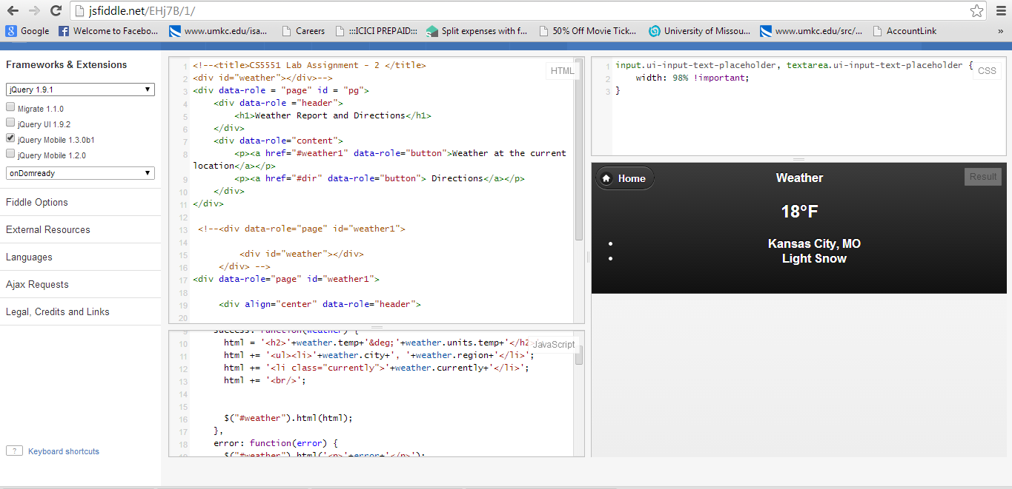

**Opera Mobile Emulator Screenshots:**

